DBSE AND DBD

Database Schema & Queries (MySQL)

Create Database
CREATE DATABASE kluh;
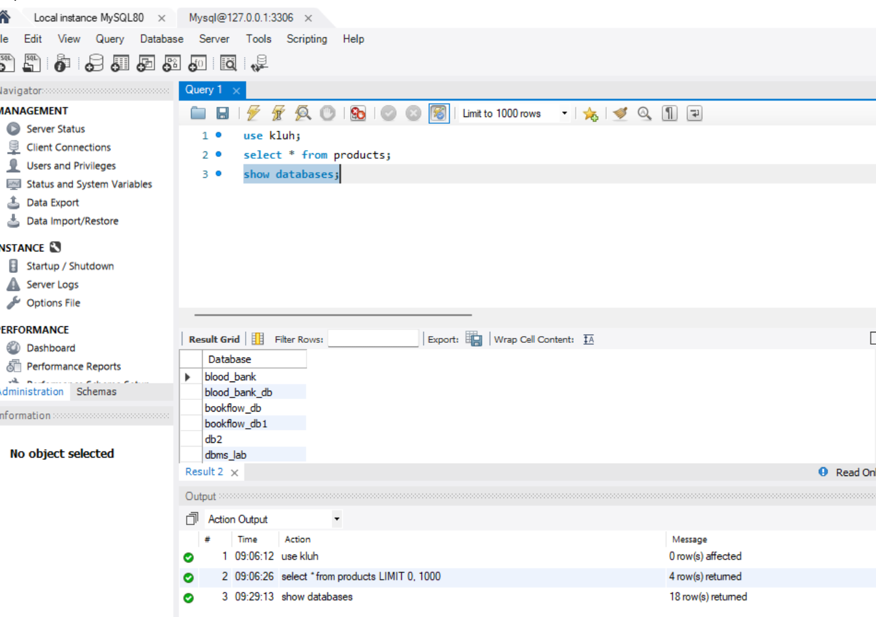

Use Database
USE kluh;

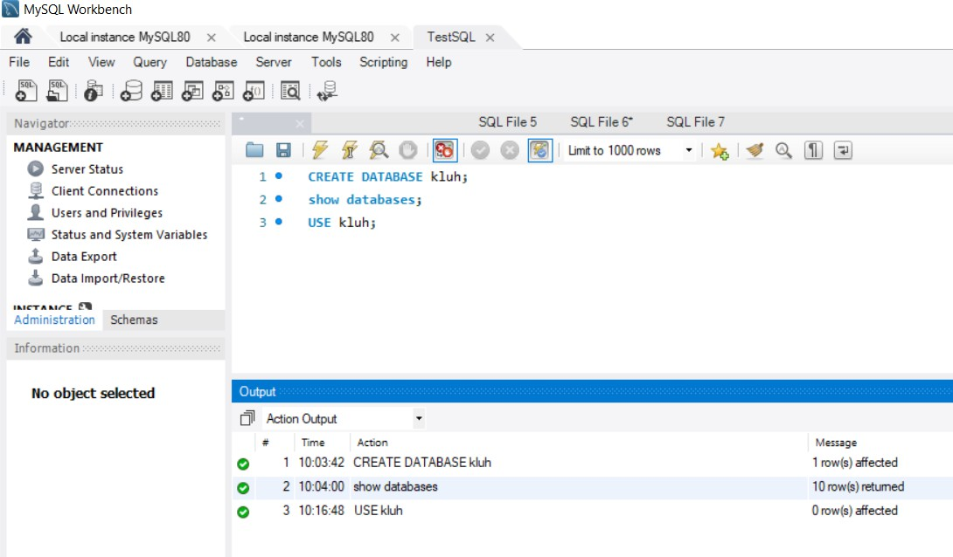

Create Table

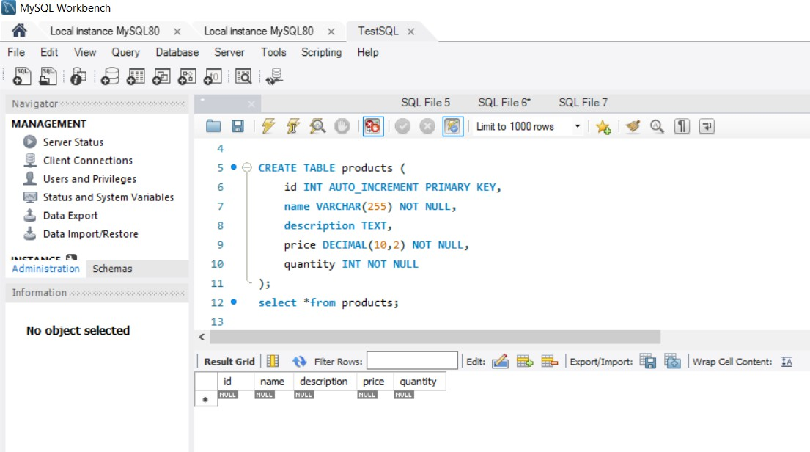

Insert Sample Data

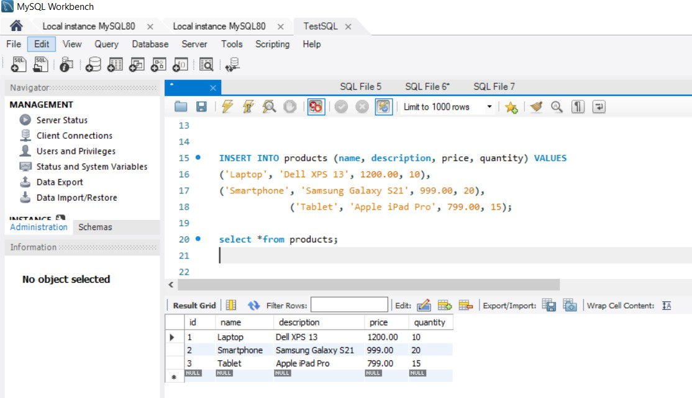

Project creation:

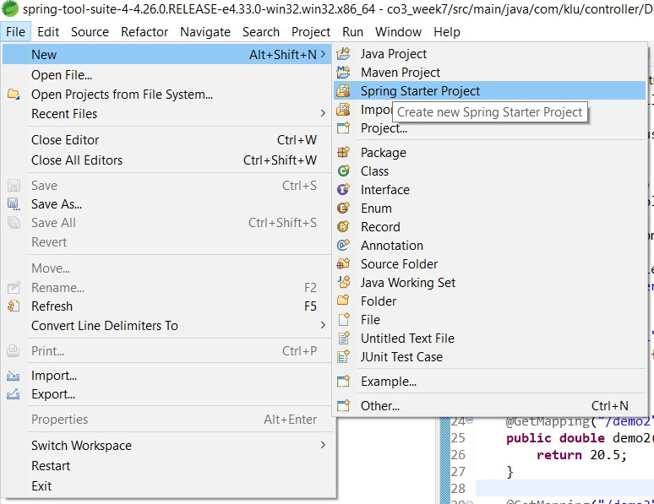
Step 1:

Step2
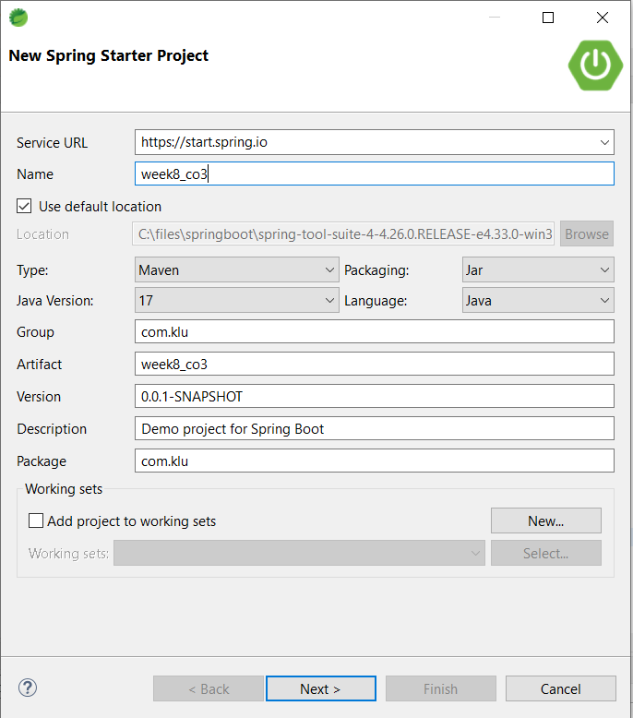

Step 3

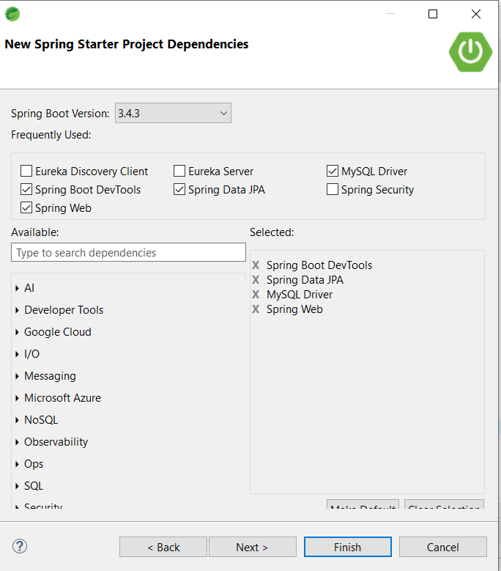

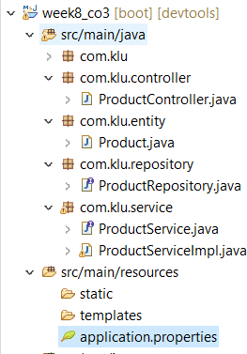

Programs:

ProductController.java

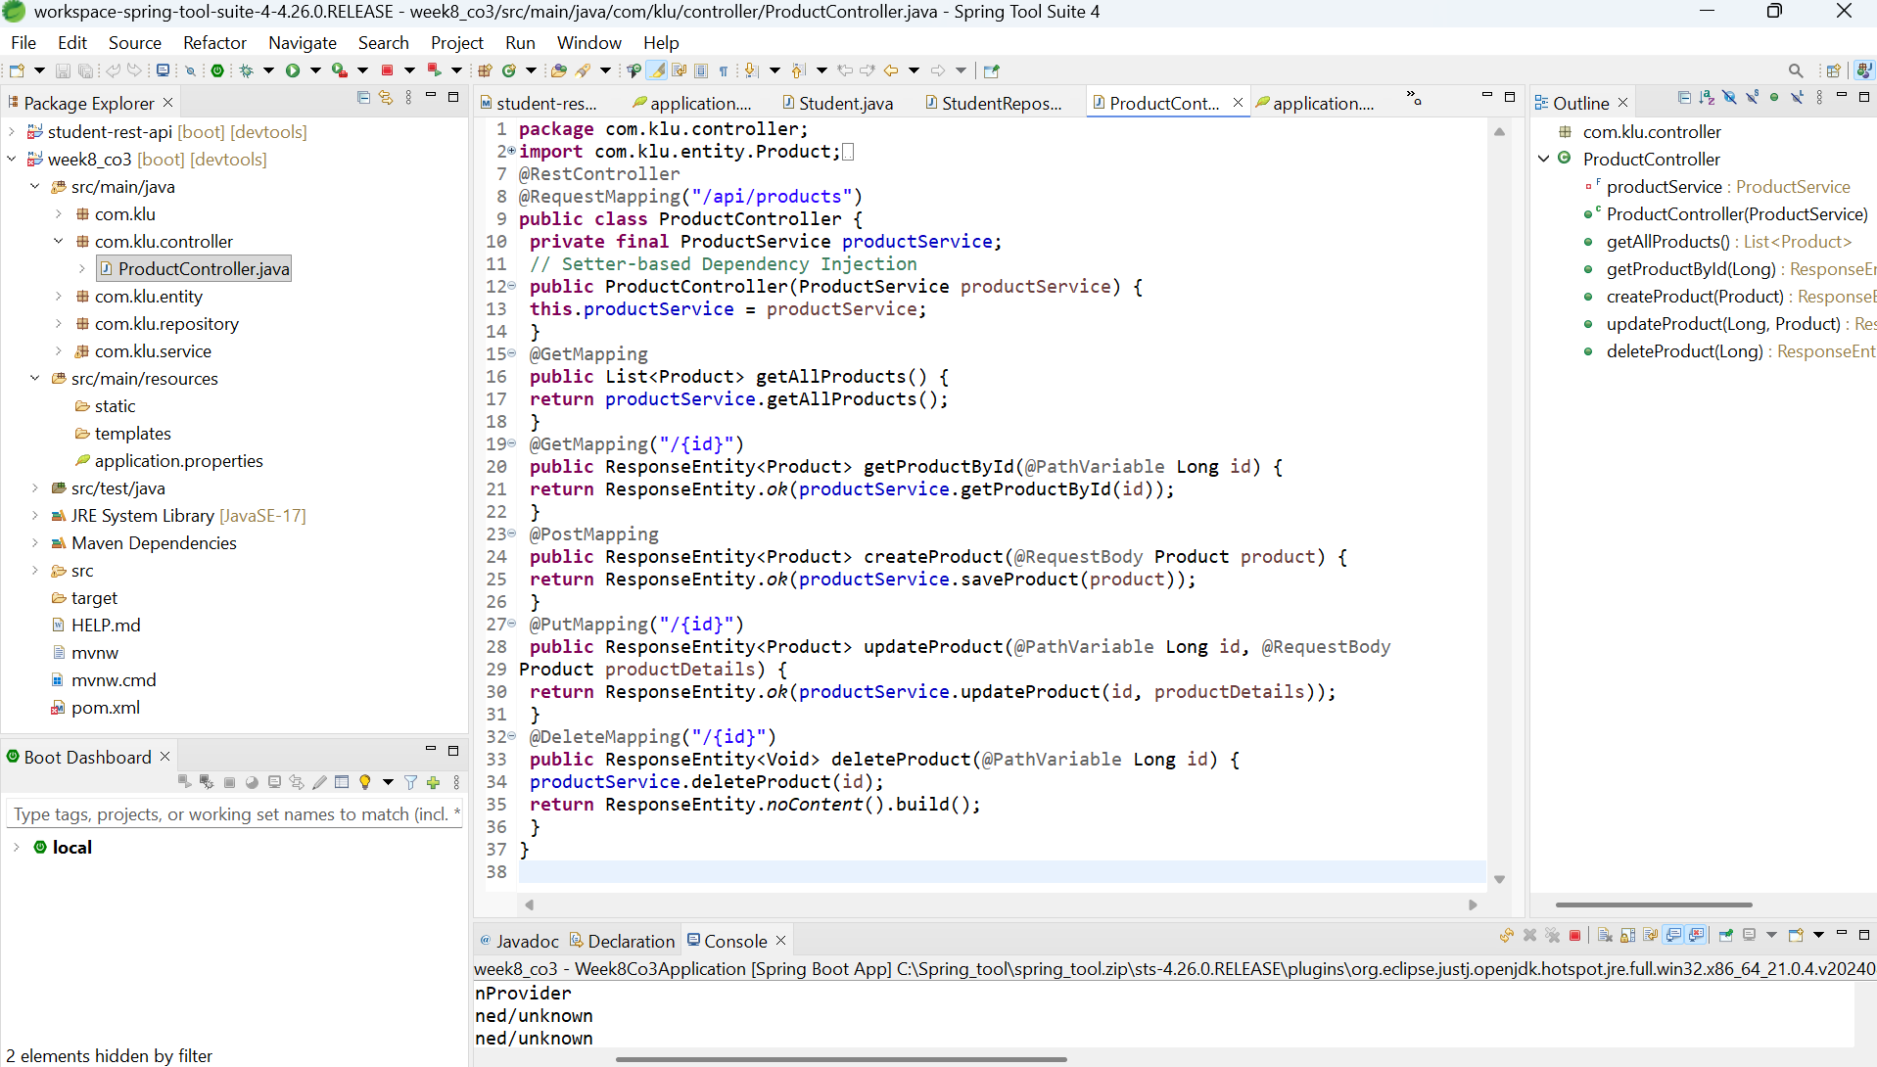

Product.java:

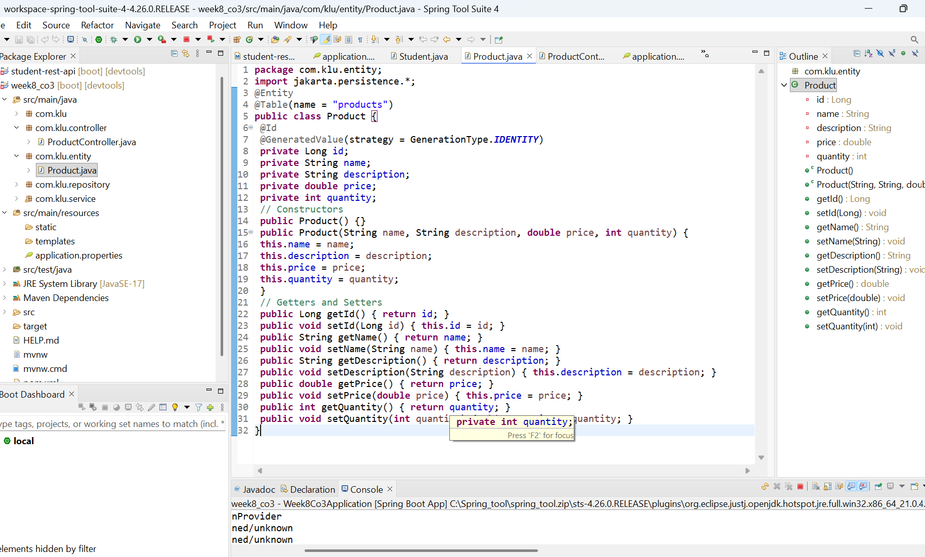

ProductRepository.java

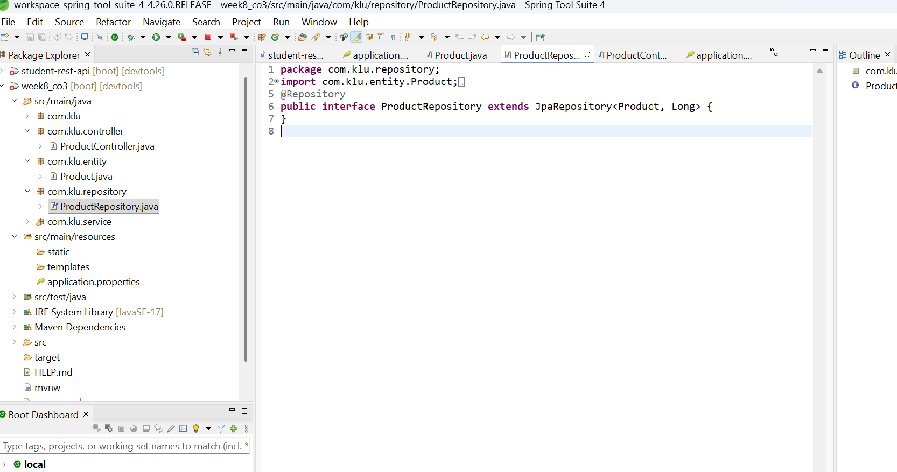

ProductService.java
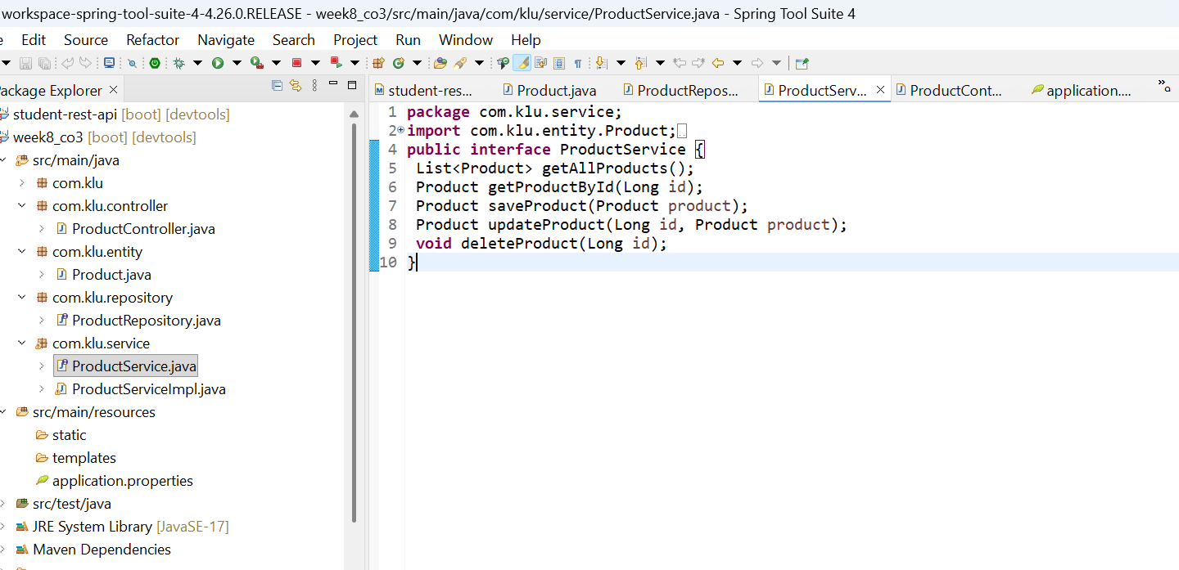

ProductServiceImpl.java

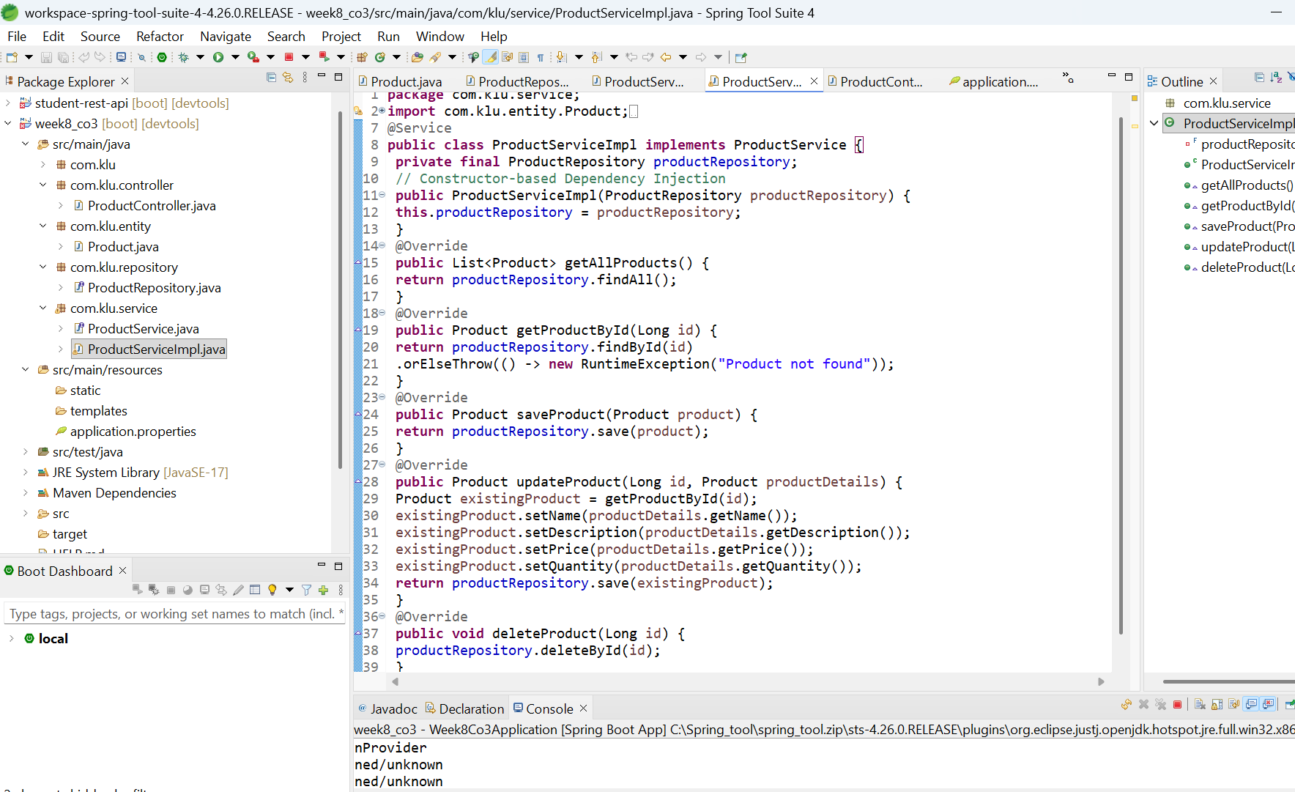

Application.properties:
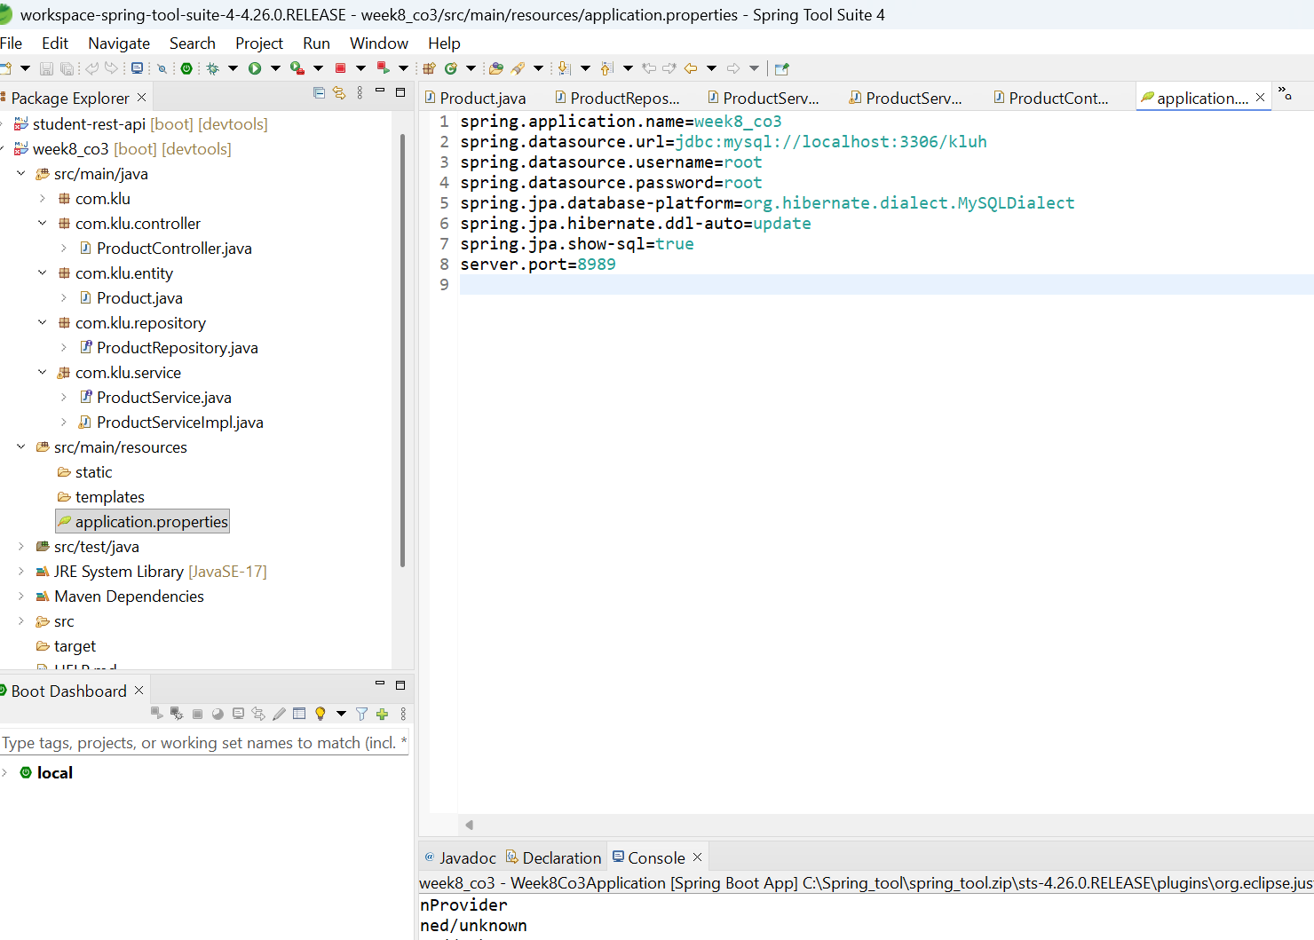

API Endpoints
HTTP Method | Endpoint | Description
GET | http://localhost:8989/api/products | Get all products
GET | http://localhost:8989/api/products/{id} | Get product by ID
POST | http://localhost:8989/api/products | Create new product

HTTP Method | Endpoint | Description
PUT | http://localhost:8989/api/products/{id} | Update existing product
DELETE | http://localhost:8989/api/products/{id} | Delete a product

Outputs:
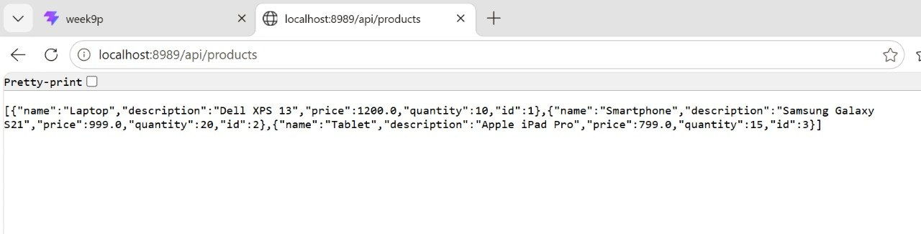

Postman testing:

1. Using get method
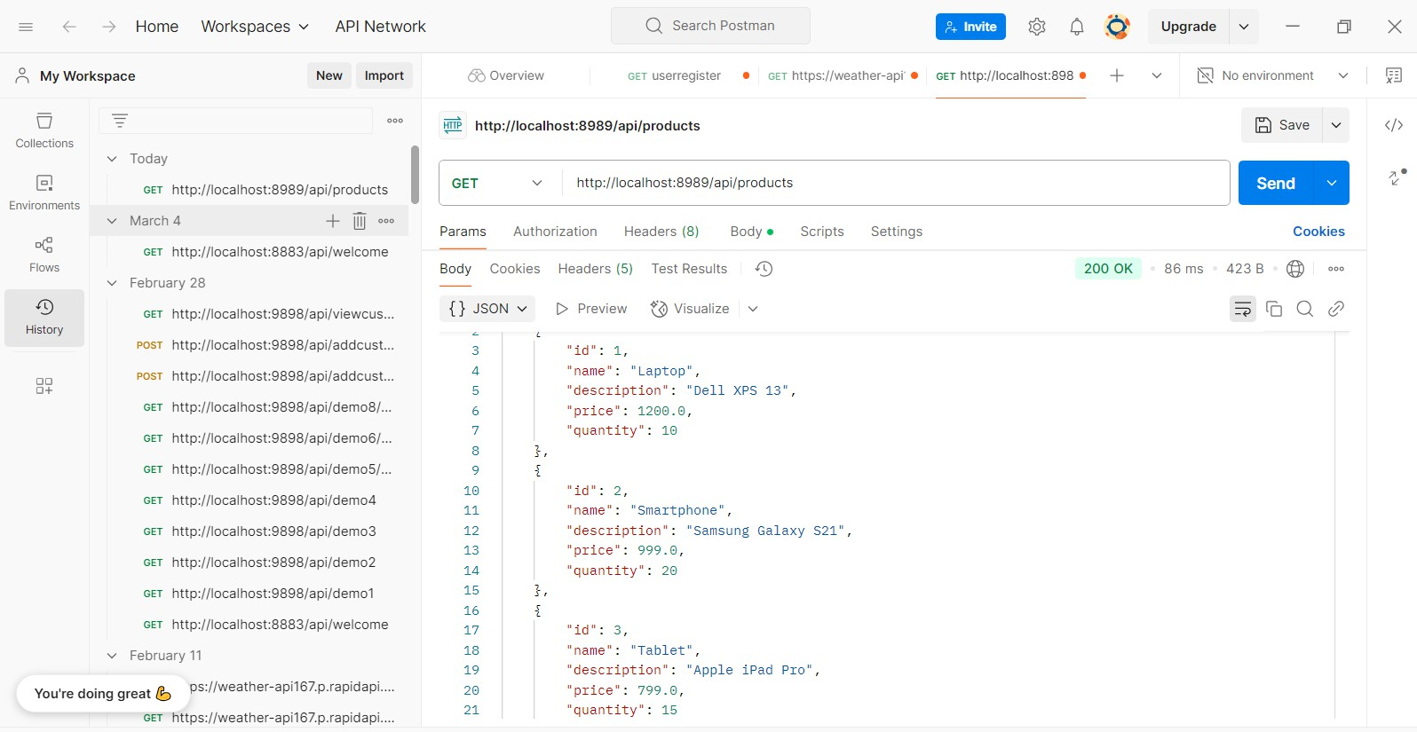

Using post method:

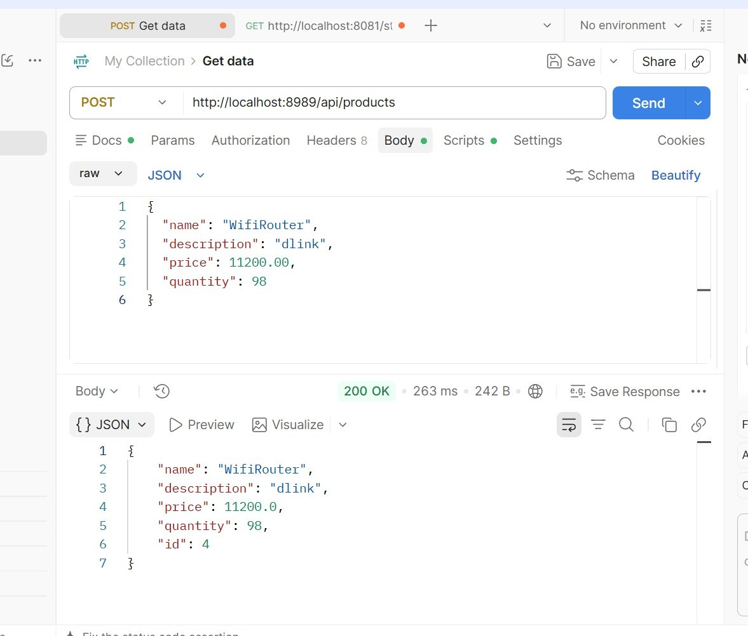

After post method ,Database table updated :
